# Literature Review

We have reviewed many real world existing 3D applications for learning human brain. They do have some amazing features, but also lack in some features such as information design, content etc. Some of them are given below:

## 3D Human Brain [1]

It is an android/windows application that contains 3D models of the human brain which you can easily use for visualization. However, it does not describe any of the four perspectives taxonomy, anatomy, physiology, or morphology.



## Brain Pro [2]

It is a mac edition 3D app that has wonderful features for the anatomical perspectives of the brain. Following are some of its main features:

1. Allows sectioned views and custom label
2. 360-degreedegree rotation and slice
3. View, Edit, and Add pins with notes
4. Layers, Map and Transparency

Some of its limitations are:

1. It does not describe other characteristics such as taxonomy, physiology, and morphology
2. It is only available for MAC.
3. It is not free

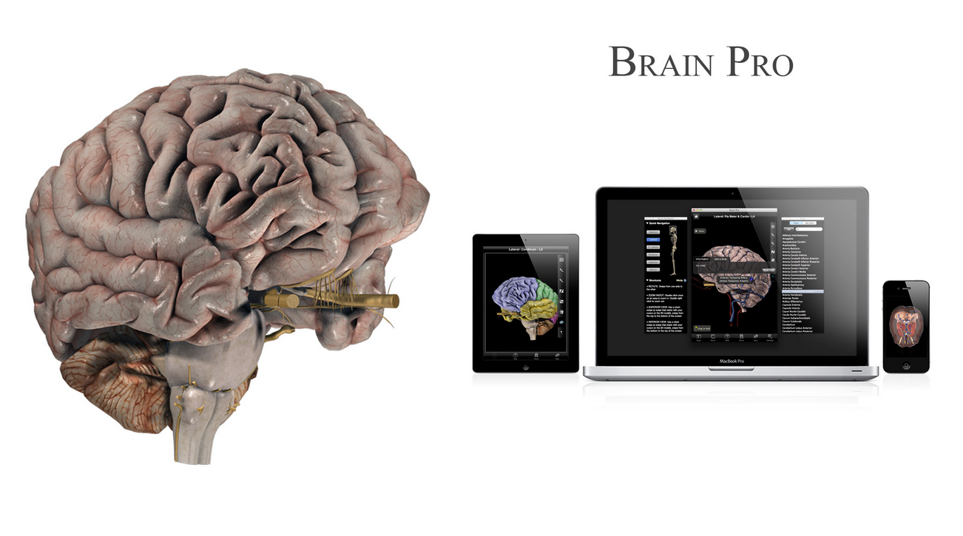

## 3D Brain [3]

It is an interactive 3D app designed for mobile devices. It is freely available and contains 29 individual maps showing different structures of the human brain. It focuses on the anatomy and physiology of the human brain. There are some issues with this app:

1. It is developed for older versions of android
2. It does not describe the morphology and taxonomy of human brain
3. It needs to have access on internal media files

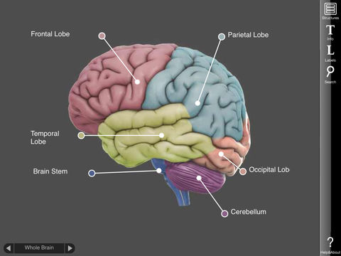

## Bio Digital Human – 3D Anatomy [4]

It is a premium app available at android play store and focuses on anatomy of human body. Some of its main features are:

1. Interactive 3D visualization
2. Scalable Content Creation and Management
3. Highly customizable visualizations
4. Easy to integrate into any Digital platform

However, it also has many issues:

1. It is general anatomy tutorial, not specific to human brain.
2. It does not focus to taxonomy, morphology, and physiology.
3. It is not freely available.

## Brain Tutor 3D [5]

It is a 3D mobile application available in the android play store. It visualizes the anatomy and physiology of the human brain. It uses the brain models developed by MRI scans. However, there are some issues existing in this app:

1. It is developed for older versions of Android.
2. It is freemium.
3. It does not have a visualization for morphology and taxonomy.
4. Its information is not so user-friendly.

# References

1. [3D Human Brain, AXON](https://apkcombo.com/3d-human-brain/axon.apps.humanbrain3d/)
2. [BRAIN PRO](https://3d4medical.com/apps/brain-pro)
3. [3D Brain, Educational App Store](https://www.educationalappstore.com/app/3d-brain)
4. [Bio Digital Human – 3D Anatomy](https://www.biodigital.com/)
5. [Brain Tutor 3D](https://www.brainvoyager.com/Mobile/BrainTutor3D_iOS.html)